**DESIGN OF A WEARABLE AMBULATORY REAL-TIME WIRELESS ELECTROCARDIOGRAM SYSTEM**

**Contents**

[LIST OF FIGURES 3](#_Toc431301064)

[ABSTRACT 5](#_Toc431301065)

[CHAPTER 1 6](#_Toc431301066)

[INTRODUCTION 6](#_Toc431301067)

[CHAPTER 2 9](#_Toc431301068)

[LITERATURE REVIEW 9](#_Toc431301069)

[CHAPTER 3 12](#_Toc431301070)

[METHODOLOGY 12](#_Toc431301071)

[3.1. Method overview 12](#_Toc431301072)

[3.2. Hardware design 12](#_Toc431301073)

[3.3. Android program for Bluetooth connection 19](#_Toc431301074)

[3.4. Web-based server 23](#_Toc431301075)

[3.6. Client side 31](#_Toc431301076)

[CHAPTER 4 36](#_Toc431301077)

[RESULTS 36](#_Toc431301078)

[4.1. The complete system 36](#_Toc431301079)

[4.2. Validation testing 39](#_Toc431301080)

[CHAPTER 5 47](#_Toc431301081)

[IMPLEMENTATIONS AND DISCUSSIONS 47](#_Toc431301082)

[CHAPTER 6 49](#_Toc431301083)

[CONCLUSIONS 49](#_Toc431301084)

[REFERENCES 51](#_Toc431301085)

# **LIST OF FIGURES**

[Figure 1:](#_Toc430247140) *[Overview of ECG telemedicine system](#_Toc430247140)* [7](#_Toc430247140)

[Figure 2:](#_Toc430247141) *[E-health model using Mobile devices, Internet and Website](#_Toc430247141)* [10](#_Toc430247141)

[Figure 3:](#_Toc430247142) *[5-Lead ECG Application](#_Toc430247142)* [13](#_Toc430247142)

*[Figure 4: Battery Charger circuit](#_Toc430247143)* [14](#_Toc430247143)

[Figure 5:](#_Toc430247144) *[Voltage Regulator circuit](#_Toc430247144)* [15](#_Toc430247144)

[Figure 7:](#_Toc430247146) *[Data Attribute diagram](#_Toc430247146)* [18](#_Toc430247146)

*[Figure 8: The complete Attribute table of ECG application](#_Toc430247147)* [19](#_Toc430247147)

[Figure 9:](#_Toc430247148) *[OSA task loop](#_Toc430247148)* [20](#_Toc430247148)

[Figure 10:](#_Toc430247149) *[The flow chart of main program](#_Toc430247149)* [21](#_Toc430247149)

[Figure 11:](#_Toc430247150) *[Flowchart of ECG\_Bluetooth program](#_Toc430247150)* [22](#_Toc430247150)

[Figure 12:](#_Toc430247151) *[BLE package format data for Android signal](#_Toc430247151)* [23](#_Toc430247151)

[Figure 13:](#_Toc430247153) *[Real-time signal plotting on ECG\_Bluetooth](#_Toc430247153)* [24](#_Toc430247153)

[Figure 14:](#_Toc430247154) *[PhpMyAdmin interfaces](#_Toc430247154)* [25](#_Toc430247154)

[Figure 15:](#_Toc430247155) *[Network diagram of telemedicine system](#_Toc430247155)* [28](#_Toc430247155)

[Figure 16:](#_Toc430247156) *[Device status displayed on admin interface](#_Toc430247156)* [30](#_Toc430247156)

[Figure 17:](#_Toc430247157) *[Android studio snippet for package data before sending to server](#_Toc430247157)* [32](#_Toc430247157)

[Figure 18:](#_Toc430247158) *[Android snippet for Url linking to 2 server classes](#_Toc430247158)* [34](#_Toc430247158)

[Figure 19:](#_Toc430247159) *[Android snippet for defining new httpObject](#_Toc430247159)* [34](#_Toc430247159)

[Figure 20:](#_Toc430247160) *[Circuit layout and complete ECG device](#_Toc430247160)* [36](#_Toc430247160)

[Figure 21:](#_Toc430247161) *[Interface of Android program](#_Toc430247161)* [38](#_Toc430247161)

[Figure 22:](#_Toc430247162) *[Process to load data from server](#_Toc430247162)* [39](#_Toc430247162)

[Figure 23:](C:\\Users\\Cu Gia Huy\\Downloads\\Thesis_HTuan_Word.doc" \l "_Toc430247163) *[Comparison on ‘Normal Sinus rhythm’ signal](C:\\Users\\Cu Gia Huy\\Downloads\\Thesis_HTuan_Word.doc" \l "_Toc430247163)* [40](C:\\Users\\Cu Gia Huy\\Downloads\\Thesis_HTuan_Word.doc" \l "_Toc430247163)

[Figure 24:](C:\\Users\\Cu Gia Huy\\Downloads\\Thesis_HTuan_Word.doc" \l "_Toc430247164) *[Comparison on ‘normal adult’ signal](C:\\Users\\Cu Gia Huy\\Downloads\\Thesis_HTuan_Word.doc" \l "_Toc430247164)* [43](C:\\Users\\Cu Gia Huy\\Downloads\\Thesis_HTuan_Word.doc" \l "_Toc430247164)

[Figure 25:](C:\\Users\\Cu Gia Huy\\Downloads\\Thesis_HTuan_Word.doc" \l "_Toc430247165) *[ECG signal of standing subject](C:\\Users\\Cu Gia Huy\\Downloads\\Thesis_HTuan_Word.doc" \l "_Toc430247165)* [42](C:\\Users\\Cu Gia Huy\\Downloads\\Thesis_HTuan_Word.doc" \l "_Toc430247165)

[Figure 26:](C:\\Users\\Cu Gia Huy\\Downloads\\Thesis_HTuan_Word.doc" \l "_Toc430247166) *[Experiment on standing subject](C:\\Users\\Cu Gia Huy\\Downloads\\Thesis_HTuan_Word.doc" \l "_Toc430247166)* [42](C:\\Users\\Cu Gia Huy\\Downloads\\Thesis_HTuan_Word.doc" \l "_Toc430247166)

[Figure 27:](C:\\Users\\Cu Gia Huy\\Downloads\\Thesis_HTuan_Word.doc" \l "_Toc430247167) *[ECG signal of sitting subject](C:\\Users\\Cu Gia Huy\\Downloads\\Thesis_HTuan_Word.doc" \l "_Toc430247167)* [43](C:\\Users\\Cu Gia Huy\\Downloads\\Thesis_HTuan_Word.doc" \l "_Toc430247167)

[Figure 28:](C:\\Users\\Cu Gia Huy\\Downloads\\Thesis_HTuan_Word.doc" \l "_Toc430247168) *[ECG measurement when the subject is sitting](C:\\Users\\Cu Gia Huy\\Downloads\\Thesis_HTuan_Word.doc" \l "_Toc430247168)* [43](C:\\Users\\Cu Gia Huy\\Downloads\\Thesis_HTuan_Word.doc" \l "_Toc430247168)

[Figure 29:](C:\\Users\\Cu Gia Huy\\Downloads\\Thesis_HTuan_Word.doc" \l "_Toc430247169) *[The subject is lying](C:\\Users\\Cu Gia Huy\\Downloads\\Thesis_HTuan_Word.doc" \l "_Toc430247169)* [45](C:\\Users\\Cu Gia Huy\\Downloads\\Thesis_HTuan_Word.doc" \l "_Toc430247169)

[Figure 30:](C:\\Users\\Cu Gia Huy\\Downloads\\Thesis_HTuan_Word.doc" \l "_Toc430247170) *[ECG signal of lying subject](C:\\Users\\Cu Gia Huy\\Downloads\\Thesis_HTuan_Word.doc" \l "_Toc430247170)* [46](C:\\Users\\Cu Gia Huy\\Downloads\\Thesis_HTuan_Word.doc" \l "_Toc430247170)

Figure 31: *The subject is walking* 46

Figure 32: *ECG signal when the subject is walking slowly and fast* 46

Figure 33*: ECG signal when the subject is running* 46

ABSTRACT

This thesis proposed a low-cost, low-power, wearable, and reliable Electrocardiogram (ECG) device aiming at long-term cardiac patient monitoring. The designed device is able to provide a set of Lead I, Lead II and V1 of ECG signals from a small footprint design attached on the the patient’s thorax. The gathered data will be securely framed and transmitted to a smart phone via Bluetooth Low Energy (BLE). Other channels constituting to 12-lead ECG signals including Lead III, Lead aVR, Lead aVL and Lead aVF are derived from the collected signals by the algorithm implemented on a cell phone. The received data will be processed, transmitted, and stored in an online server that can be securely accessed from any particular healthcare center for further investigation or references. Compared to current ECG monitoring system in both research lab and clinical settings, the proposed wearable ECG system and data management platform can provide significant improvements in terms of signal quality, monitoring duration, device mobility, and system integrability. Such improvements will critically enhance the at home diagnosis and treatment of chronic cardiac disorders such as arrhythmia and atrial fibrillation.

# CHAPTER 1

INTRODUCTION

* 1. **Overview**

Cardiovascular disease has become social and economic burdens as it is among the main sources of mortality not only in Vietnam but also in the world. The World Heart Federation (WHF) estimates that up to 20 percent of Vietnam's population will endure cardiovascular related health problems by 2017. The World Health Organization (WHO) assessed that 17.5 million individuals pass on of cardiovascular disorders consistently on the planet and the number is on the ascent. Direct and indirect cost for the diagnosis and treatment of patients with cardiovascular illnesses including hypertension, heart failure, stroke and myocardial infarction, coronary artery disease, and atherosclerosis add up to billions of US dollars every year [[1](file:///C:\\Users\\Cu%20Gia%20Huy\\Downloads\\Thesis_HTuan_Word.doc" \l "_ENREF_1" \o "Loi, 2014 #1)].

The proposed “Wearable Wireless ECG Monitoring system” plans to bring home better condition of medicinal services for the individuals living in Vietnam, where a large number of death related to cardiovascular disorders happen every year because of absence of specialists and facilities.

* 1. **Objectives and scope of project**

The objectives of this project are to implement and validate a wearable, wireless and long-term ECG monitor. The device can collect in real time 4 channels of Electrocardiogram (ECG) signals and derive 4 other channels for two consecutive days without charging the battery. Moreover, the device can provide an alternative Holter ECG monitor that are comfortable and unobtrusive for the users in different daily activities. In addition, we developed a data management for telemedicine healthcare application on Android smartphone in which signals are wirelessly transmitted from the ECG acquisition module to the phone via Bluetooth and therefrom the processed data will be sent to the online server via TCP/IP sockets or Internet web-based server. The figure below shows an overview of our projects:

**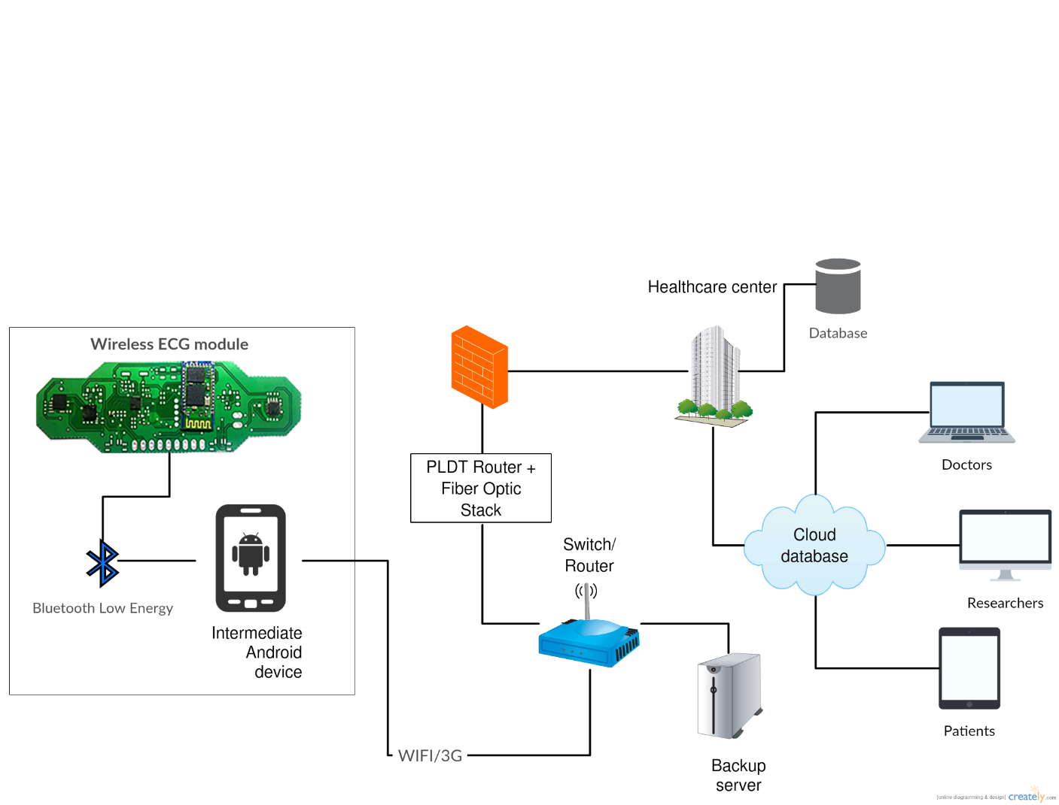**

**Figure 1***: Overview of ECG telemedicine system*

The application scope of this project concentrates on the clinical healthcare settings. The implemented system can be utilized to provide affordable patient monitoring device at the doctor's facilities, clinics, and hospitals in Vietnam. These attempts to lessen the weight of expense and give the users access to the wellbeing checking gadgets that can help in risk-free operations and upgraded therapeutic consideration to improve the health quality of the population. The project additionally performs for real-time streaming of the gathered medicinal data to a central server located at a multi-specialty medical institution. Moreover, doctors are furnished with a noteworthy level of data about a patient's status.

The developed system have been validated in different clinical setting to access both performance and reliability. The monitoring function will be validated in a clinical test in which the patients perform some ordinary exercises as they do in their daily life likewise with some interventions while wearing both the monitor developed in this project and a commercially available monitor. Interventions will incorporate exercises extending from resting to running to simulate what wearing the monitor for during the days would be like. The heart screen will be approved in the event that it executes as well (if not better) as the industrially ECG monitor and has the capacity withstand consistently movement while being both sensibly comfortable and unobtrusive.

The organization of this thesis is as follows:

* *Chapter 2:* literature review revises state-of-the-art works related to ambulatory ECG devices and telemedicine systems.
* *Chapter 3:* methodology presents the hardware, firmware and software details.
* *Chapter 4:* Implementation and discussions provide the validation results and explains the findings.
* *Chapter 5*: Conclusion chapter summarizes proposed work and recommends future research

# CHAPTER 2

# LITERATURE REVIEW

A crucial aspect of the design process was determining the feasibility of a Low-Cost wireless ECG system. Rising advancements, for example, cloud computing and Internet of Things have made a world, which is progressively connected. The continuous progress in the field of vital sign acquisition, especially the wearable ECG device will take this common pattern to the next level. These ubiquitous, smart device will help patients to be more mindful of their disorders. A late study even found that users of this innovation feel more safe, self-confident and in control of their lives. Yet, on one hand, a signal acquisition device is just comparable to the information it conveys, on the other hand, wearable innovation will just accomplish acceptance in the mass market on the off chance that it is unobtrusive and fits as a natural extension of the human body. In this manner, these gadgets should be intended for both capacity and style. To achieve this level of solace, such a system should be flawlessly integrated in a compact device that minimum the wires and weight. At this time, there are such remarkable achievements in investigating wearable ECG system. First of all, the traditional Holter ECG devices of GE, Phillips have been a reliable choice for most of hospitals or healthcare centers in the world. More than that, IMEC [[13](file:///C:\\Users\\Cu%20Gia%20Huy\\Downloads\\Thesis_HTuan_Word.doc" \l "_ENREF_13" \o "Lobodzinski, 2 0 1 3  #14)], Qardio and other research from Universities [[14](file:///C:\\Users\\Cu%20Gia%20Huy\\Downloads\\Thesis_HTuan_Word.doc" \l "_ENREF_14" \o "Etemadi, 2015 #15)] now have leading the revolution of wearable ECG device in research and clinical use [[15](file:///C:\\Users\\Cu%20Gia%20Huy\\Downloads\\Thesis_HTuan_Word.doc" \l "_ENREF_15" \o "Huang, 2014 #17)]. Those companies has brought to the mass market the high quality wearable ECG patch aiming at long term patient monitoring [[16](file:///C:\\Users\\Cu%20Gia%20Huy\\Downloads\\Thesis_HTuan_Word.doc" \l "_ENREF_16" \o "Olmos, 2014 #18)].

Telemedicine has been first developed in United State in 1987 with the foundation of the International health Level Seven (HL7) organization [[11](#_bookmark7)], which later changed into American National Standards Institute (ANSI). At beginning of 21th century, the age of health telematics came with the rapid development in both quality and quantity. During this time, the evolution of Web infrastructure and electronic health records (EHRs) [[30](#_bookmark12)]. The telemedicine was developed on the base of EHRs, which then extends to become a public healthcare system [[31](#_bookmark13)]. Recently, a huge amount of telemedicine and e-Health systems are being developed and delivered using different wireless communication technologies. Some trademarks are Wifi, Bluetooth, 3G/4G, Zigbee. Smartphone industry has significant change in its state of art, which now widely and rapidly occupies mobilephone market. Higher technology allows manufacturers integrate multiple sensors and communication protocols into a hand-held device. E-health model using Internet and Website is demonstrated in figure 1.

**Figure 2***: E-health model using Mobile devices, Internet and Website*

Gregoski *et al*. [[32](#_bookmark14)] implemented an Android application using smartphones’ camera to get heart rate parameter. This result was compared with an ECG device and a pulse oximeter. The correlation between those devices was analyzed and 95% is the level of agreement. Although further validation was need to determined, the result proposed a novel usage for health promotion and wellness telemedicine program. In 2001, Hernandez, A.I *et al*. [[33](#_bookmark15)] investigated a real-time ECG acquisition, transmission and visualization via Internet. The data is transmitted from a remote, non-clinical area to hospital, clinic for physicians. In this work, a prototype was established including: a portable ECG module, a java-based server-client platform, software module.

**CHAPTER 3**

# METHODOLOGY

3.1. Method overview

This chapter gives a brief description of the main methodologies which were utilized in this work. It will also illustrate the proposed system by decomposing it into 4 parts, which are *Hardware design*, *Android for BLE connection, Web-based server and client side*.

3.2. Hardware design

3.2.1. Design requirements

Table 1: Design Requirements

|  |  |
| --- | --- |
| DESIGN PARAMETER | VALUE |
| Number of electrodes | 5 |
| Lead I definition | LA - RA |
| Lead II definition | LL - RA |
| Lead V definition | V1 - WCT |
| Bandwidth | 175 Hz |
| Output data rate | 853 Hz |
| Analog supply voltage | 3.3 V |
| Digital I/O supply voltage | 3.3 V |

3.2.2. Analog Front-End circuit

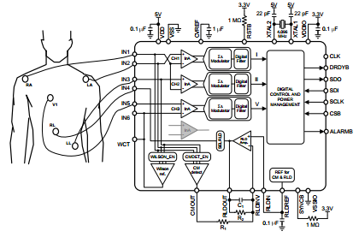

Figure 3: *5-Lead ECG Application*

In the 5-lead ECG mode, the analog chip uses the Common-Mode Detector to measure the common-mode of the system by averaging the voltage of input pins IN1, IN2, IN3, and uses this signal in the right-leg feedback circuit. The output of the RLD amplifier is connected to RL through IN4 to drive the common-mode of the system. The Wilson Central terminal is generated by the IC and is used as a reference to measure the chest electrode, V1. The Wilson Central terminal is defined as the average of the three limb electrodes, RA, LA, and LL:

Wilson Central Terminal = (RA + LA + LL)/3

Fives input pins of the chips which are IN1, IN2, IN3, IN4, and IN5 are connected to RA, LA, LL, RL, and V1 respectively. The chip uses an external 4.096 MHz crystal oscillator connected between XTAL1 and XTAL2 pins to create the clock source for the device.

3.2.3. Battery Charger circuit

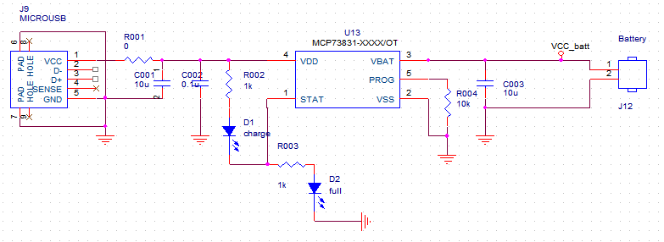

Figure 4: *Battery Charger circuit*

At the input supply, a 5V power supply is provided via the micro-usb port. The input supply is bypassed to Vss with a 10 uF capacitor. The Vss is the battery management 0V reference, which is connected to negative terminal of battery and input supply-the circuit’s ground. The charger’s currents are scaled by placing a resistor form PROG pin to Vss. The charger’s output (VBAT) is connected to positive terminal of the battery and bypassed to Vss with a 10 uF capacitor to ensure loop stability when the battery is disconnected. The STAT pin is an output for connection to two LEDs for charge status indication. When the LED D1 is on, the charger is working, and the LED D2 is on when the battery is full.

3.2.4. Voltage regulator circuit

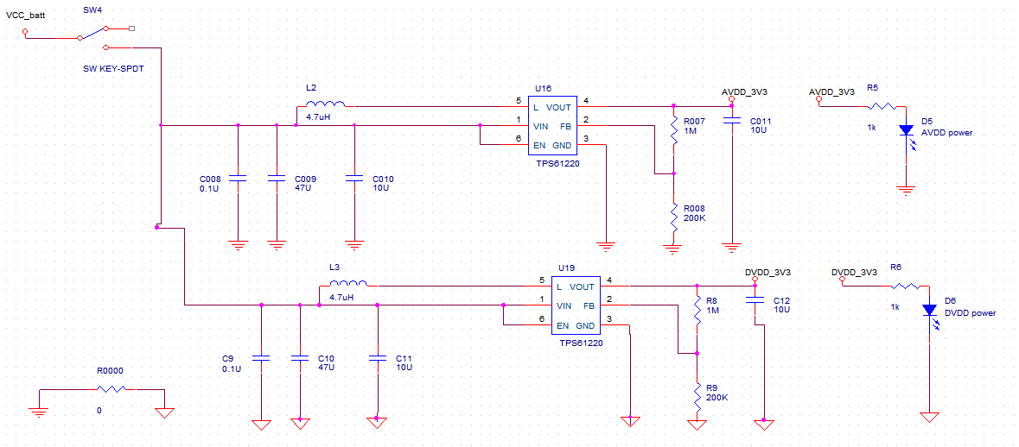

Figure 5: *Voltage Regulator circuit*

The voltage regulator circuit is separated into two parts, one for the Digital power supply and the other for the Analog power supply. The reason to isolate the power sources of the Digital and Analog circuit is to eliminate the noises. The input supply and electrical element for both circuits are totally the same, but the output voltages are separated with different grounds which are connected to each other via a 0-Ohm resistor.

With 3.3V DC supply for both analog and digital circuit, and the use of lithium-polymer battery, two TPS61220 chips were used. The EN pin is driven high by connecting to VIN- input voltage to enable the TPS61220. The capacitors that connect the input and output of the TPS61220 to Ground were used to stabilized and filter the rectified voltage.

3.2.5. BLE Protocol Stack Basics

Figure 6: *BLE protocol stack architecture*

The controller and the host are two sections of the protocol stack. Starting from the bottom of this architecture, the Physical Layer includes the BLE hardware which are balun and antenna. The LL controls five RF states of the device which are:

* Standby: ready and waiting for connection.
* Advertising: transmit data without being in a connection.
* Scanning: Listen for any device that is in advertising mode
* Initiating: responding to an advertising device with a connection request.
* Connected: when the advertiser accepts the connection request, both the advertiser and initiator will enter a connected state. The initiating device is the master while the advertising device that accepted the request is the slave.

The HCI layer provide the standard interfaces for communication between the host and controller. The standardized interfaces are software API, or hardware interface such as UART, SPI, and USB.

The L2CAP layer do the data encapsulation to the upper layers while the SM layer regulates the methods for pairing and key distribution for the other layers to connect and exchange data securely.

The GAP layer interfaces with the application and profiles, and the ATT protocol exposes certain pieces of data to another device.

The GATT layer defines the guidelines for the BLE devices, which are the server and the client. All data exchanged between two BLE devices are handled by GATT profile.

In BLE protocol, the data are called Attributes and grouped as the figure below:

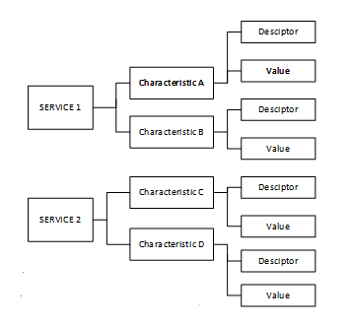

Figure 7: *Data Attribute diagram*

One characteristic can have multiple descriptors which are all related with a 128-bit UUID which can be known as an address. This UUID allows the programmer to access to the right service and the value contained within the characteristics.

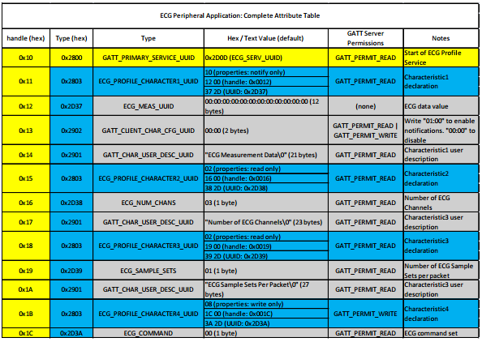

**Figure 8:** *The complete Attribute table of ECG application*

Operating system abstraction layer (OSAL) controls all tasks and priorities of stack layers, provide communication between higher stack layers and lower layers by registering callback functions. To create an application to communicate with the AFE and transfer data, a custom profile must be created. In this profile, a 16-bit UUID which is 0x2D37 is used to identify characteristic of the ECG service. This application is set to be a task of the OSAL queue, when the task is up for execution, the values in the characteristics are read and transmitted to the connected device.

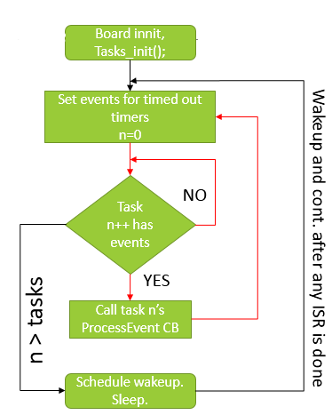



3.3. Android program for Bluetooth connection

After designing ECG module, an Android program called “ECG\_Bluetooth” was created in order to test the signal transmission from ECG module via BLE. Taking inspiration from Sensor Tag product of Texas Instrument, which is used BLE to transmit parameter from Sensor Tag to smartphone or tablet, the ECG\_Bluetooth is designed. The program flow chart for BLE connection part is shown in Figure 13.

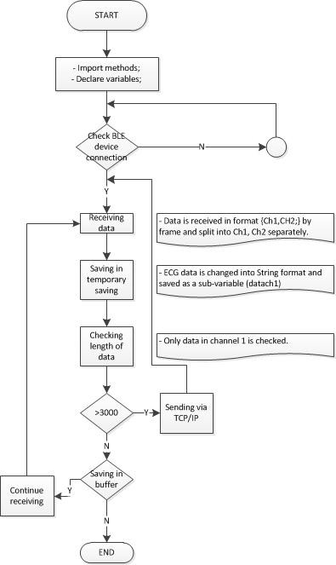

**11**

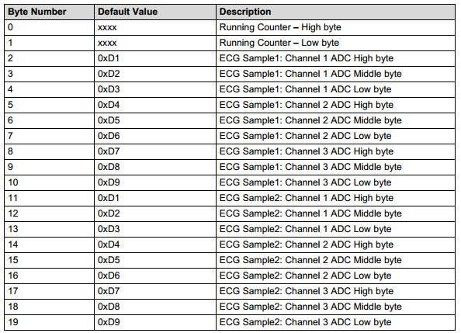

**Figure 12***: BLE package format data for Android signal sending and receiving*

The signal is received byte-to-byte from ECG module. Each byte will be added to an string by *updateLongText()* function. A buffer is used to store data, if the length of data is larger than 3000 bytes, the TCP/IP protocol or Web-based protocol will be calledsplaying

In order to plot real-time signal on smartphone, a third-party library is used, “Achartengine” (4ViewSort Co., Romania). Achartengine is an open-source graphing library for Android developers. Among similar libraries, such as GraphView,

AndroidChart, etc Achartengine has huge advantages in low-cost computing, real-time plotting and its popularity. There are about 0.52% Android programs, around 600 thousands, on Google Play market using Achartengine according to appbrain.com, a statistic company on mobile application market.

Adding charting to an Android application with AChartEngine, is as simple as adding the achartengine-x.y.z.jar to the application classpath and start coding against its APIs. The current stable version is 1.0.0 and the one under development 1.1.0. The jar file is only 110 KB is size, which is quite a small footprint nowadays. However, AChartEngine offers support for many chart types, from LineChart, BarChart, ScatterChart to PieChart, real-time (or dynamic) chart. In this project, Achartengine is used to create a graphing background for 3 ECG channels real-time. When number of received data is larger than 3, the graphing library is initiated. It takes gradually each sample in store buffer and adds into the graph. Range of x-axis is configured at the beginning. Therefore, when data’s reached the limitation, window will move forward. The moving keeps moving continuously until users touch or roll back.

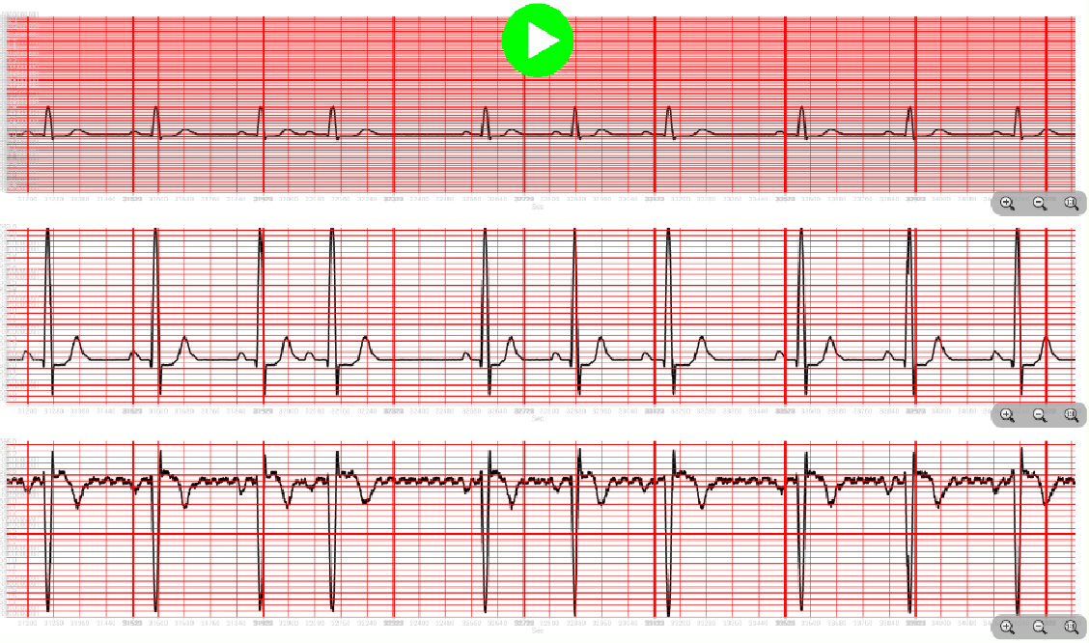

**Figure 13***: Real-time signal plotting on ECG\_Bluetooth interface using AChartEngine* *library on Android Studio*

3.4. Web-based server

3.4.1. php server program

During project, a local offline server is firstly used for testing. XAMP server, which is a completely and friendly Apache distribution containing MySQL, PHP, and Perl, is used as the main database. XAMP is a Window web development environment. This is an open source package has been set up to be increasingly easy to install and used. Alongside, phpMyAdmin allows developers to manage the databases easily.

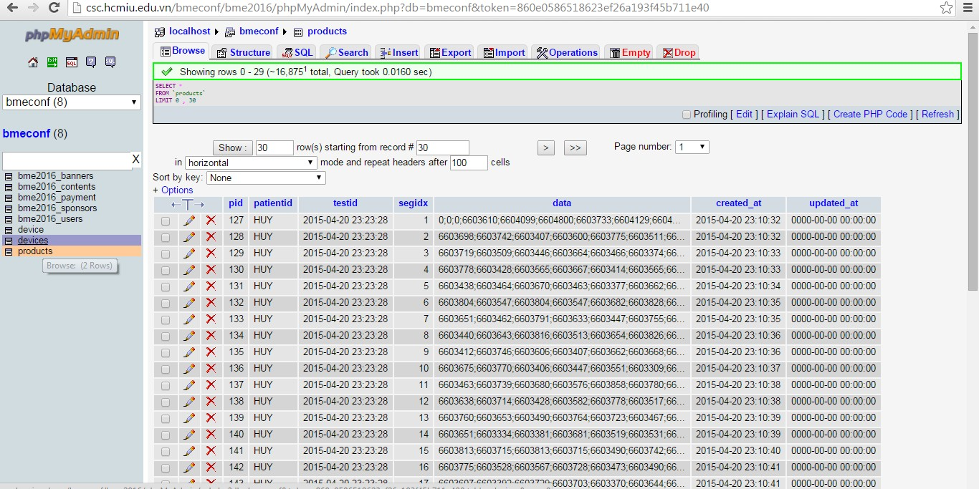

**Figure 14***: PhpMyAdmin interfaces*

For the final product, the database was uploaded into Internet via address:

***<http://csc.hcmiu.edu.vn/bmeconf/ecg/>***

|  |  |
| --- | --- |
| CLASS | FUNCTIONS |
| chart3.php | - Plotting real-time or historical for screening. |
| create\_product.php | - Create new patient record in the “products” table. |
| db\_config.php | - Configure the access information including user name, password, database to login the main database. |
| db\_connect.php | - Connect to database using sql commands |
| get\_data.php | - Load data of specific patient from database and display on Android interfaces. |
| update\_device.php | - Update status of device, in which “0” is offline and “1” is online |

Table 3: Function analysis of website “<http://csc.hcmiu.edu.vn/bmeconf/ecg/>”

3.4.2. Database structure

In this project, ECG records are stored in website database, which can be accessed by PhpMyAdmin. There are two tables in database: devices and products.

* “devices” table contains 3 fields: deviceID, status and testid. “deviceID” represents the device’s name, which is the primary key of table. This value is in varchar form. “Status” shows the status of device, which has 2 value “0” and “1”. The last one, “testid” is the timestamp of record. It is used as the foreign key of the “products” table.

|  |  |  |  |  |
| --- | --- | --- | --- | --- |
| Table | Field | Type | Description | Example |
| products | pid | Int | Primary key, increment | 1,2,3 |
| patientid | Varchar | Patient’s name | HUY, TUAN |
| testid | Timestamp | Test’s time | 2015-04-20 23:23:28 |
| segidx | Int | Order of segment | 1,2,3 |
| data | text | ECG data | 1225896;6603610;6604099 |
| devices | deviceID | Varchar | Primary key | 6C:EC:EB:15:54:87 |
| status | Int | “1” or “0” | 0,1 |
| testid | Timestamp | Test’s time | 2015-06-15 11:22:50 |



**Table 4**: *Database structure of phpMyadmin*

3.4.3. Program structure

As mentioned in table above, there are 6 PHP files used in this website part, in which 4 of them (create\_product.php, db\_config.php, db\_connect.php, update\_device.php) are used as server side, while the others (chart3.php and get\_data.php) are in client side. In this part, the first 4 classes will be discussed in detail, while two other will be mentioned in next session.

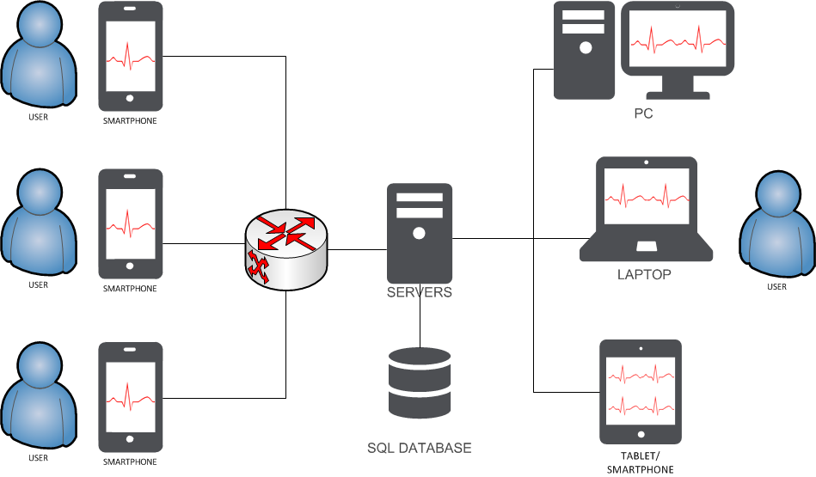

**Figure 15:** *Network diagram of telemedicine system*

1. db\_config.php

This file is used to declare 4 essential parameters for database logging in, which are database user, database password, database name and database server. The following code shows how those values are defined.

1. db\_connect.php

An internal class in this file, DB\_CONNECT, plays role to connect to database. The functions of this class include: importing database connection variables, connecting to mysql database, selecting database and returning connection cursor. Those parameters were accessed from db\_config.php class.

1. Create\_product.php

This is the main class to create new patient record. At first, the parameters about record information, which are patientid, testid, segidx, data, are checked. If one of them is null, the result: “An error occurred.” is shown. Otherwise, the connection to database will be created.

$db = new DB\_CONNECT();

Then, a SQL command is used to insert new data into table. This command is mysql\_query and method INSERT is implemented. This command plays role to add set of data into a new row of database table with the values of patient id, test id, segment id and data.

update\_device.php

This class is used to update working status of a specific device. There are two value “0” and “1”, which represent offline and online status respectively. At first, the data is set “0”. When the Android application is executed, the first call of sending data function will lead to the start of this class. The status will then change to “1” by the command mysql\_query and “UPDATE” method. After closing application, this class is called again to change status to “0”. Therefore, the users and administrators are able to track if any device is running or not. In case of losing Internet connection for long period, the status would be “0”.

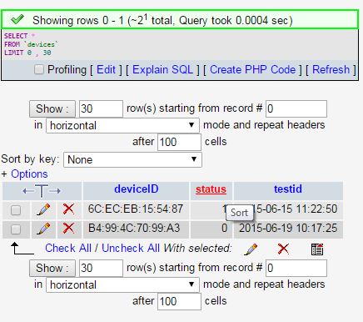

**Figure 16***: Device status displayed on admin interface of website “<http://csc.hcmiu.edu.vn/bmeconf/ecg/>”*

3.6. Client side

The main purpose of client is to send data to server (in Android application) and to retrieve and display ECG data in real-time (in Android and website application).

3.6.1. Introduction

The previous method, TCP/IP socket, shows disadvantage in outside of local area transmission. The web-based server transmission overcomes this weakness by sending ECG data directly to internet server through Wifi or 3G. This transmitting pathway is sustainable because concurrently, Vietnam area is almost covered by the telephone network, in which 3G is also support. In urban area, Viettel 3G service is guaranteed for wireless transmission, while in rural one, other suppliers, such as Vina or Mobiphone, have advantages. As the result of testing, transmission is stable in almost area in our country. Therefore, this method is believed to be a suitable solution for ambulatory ECG development.

3.6.2. Program working principles

In order to send data to website server, JSON (JavaScript Object Notation) format is used. JSON is a lightweight text-based open standard designed for human\_readable data interchange. To make the connection to PHP files, HTTP protocol is used from the Android system. JSON object used list of pair data in order to parse in.

In general, the transmission function is executed in two java class: HM10Activity.java and JSONParser.java. In the beginning, the HM10Activity.java class creates the URL linked to PHP files, create\_product.php and update\_device.php, then declare a “jsonParser” variable, which is accessed from JSONParser.java class. A “HTTPObject” function is defined to run parallel with the main activity using backgroundWorker method. This function plays role in collecting data, putting in list and sending to server. Then, in order to collect data, a List<NameValuePair> named “params” is initialized. During working, the patientid, testid, segidx and data are added into this list using following snippet:



sent\_count **=** sent\_count **+** maxsent**;** segidx **=** sent\_count**/**maxsent**;**

params**.**add**(new** BasicNameValuePair**(**"patientid"**,** "HUY"**));** params**.**add**(new** BasicNameValuePair**(**"testid"**,** time\_stamp**));** params**.**add**(new** BasicNameValuePair**(**"segidx"**,** Integer**.**toString**(**segidx**)));**

params**.**add**(new** BasicNameValuePair**(**"data"**,** tmp\_data**));**

**Figure 17***: Android studio snippet for package data before sending to server*

The JSONObject json is define as “POST” method to send those values using 3 parameter: url, “POST”, and params.

3.6.3. Program structure

There are two main classes used in this part of Android application. The general functions of those are represented in Table 5.

**Table 5***: Android function summary for retrieving data from server*

|  |  |
| --- | --- |
| CLASS | FUNCTION |
| HM10Acitivity.java | * Rreceiving data from BLE module * - Processing signal and storing in buffers * Sending data to server using Http method from JSONParser.java |
| JSONParser.java | * - Implementing Http method * - Posting or Getting data |

1. HM10Activity.java:

HM10Activity.java class imports 2 methods from org.apache.http: NameValuePair and message.BasicNameValuePair in order to initiate the list for storing “params” in next step. In addition, the method org.json.JSONObject is also declared.

Then, the addresses of create\_product.php and update\_device.php are put into 2 strings “url\_create\_product” and “url\_update\_status” respectively.

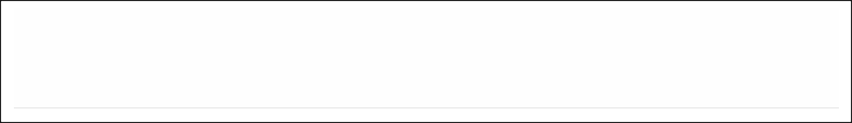

public static String url\_create\_product **=**

"<http://csc.hcmiu.edu.vn/bmeconf/ecg/create_product.php>"**;** public static String url\_update\_status **=**

"<http://csc.hcmiu.edu.vn/bmeconf/ecg/update_device.php>"**;**

**Figure 18***: Android snippet for Url linking to 2 server classes*

Next, the JASONParser variable, which is accessed from JASONParser.java class, is defined along with the new HTTPObject for creating new data set of record.

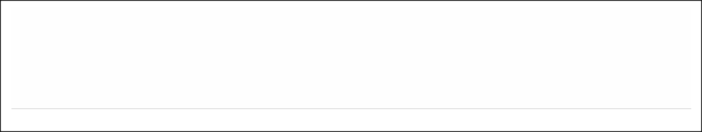

JSONParser jsonParser **= new** JSONParser**();**

public CreateNewProduct HTTPObject **= new**

CreateNewProduct**();**

public UpdateData HTTPObject1 **= new** UpdateData**();**

**Figure 19:** *Android snippet for defining new httpObject*

The connection activity is checked if it is running or not in the onReceived function. If it is not running, the activity is executed.

In the doInBackground() function, which is used to execute program in parallel with the main activity, the “params” variable is declared. After receiving from ECG module through BLE, the data is stored in “tmp\_data” variable, which is in String format. The number of value is checked if it is 100 or not. If so, data will be added into “params” in pairs, with 4 parameters: patientid, testid, segidx, data, in which the first one is taken from input at the beginning, the second one is timestamp at that moment, “segidx” is defined by the times of sending data, while the last one is ECG data.

1. JSONParser.java

JSONParser.java generates function “makeHttpRequest” with 3 inputs: the URL, method (“Post” or “Get”), and params. In detail, the process to upload data begins by checking the method whether it is “POST” or “GET” one, in this case “POST”. Next, the declaration of httpClient method is called. Then, the method HttpPost is used, which is implemented the URL of the PHP files, in this case create\_product.php and update\_device.php. The set of data, which is now called “params”, is implemented. Finally, the sending process is executed, in which a connection is generated between client and server. Server is able to receive the package sending from client.

# CHAPTER 4

# RESULTS

4.1. The complete system

The completed product with the diameter of 3.5cm was showed in the figure below and gave significantly positive result in recording and sending real-time ECG data from body to smartphone via Bluetooth.

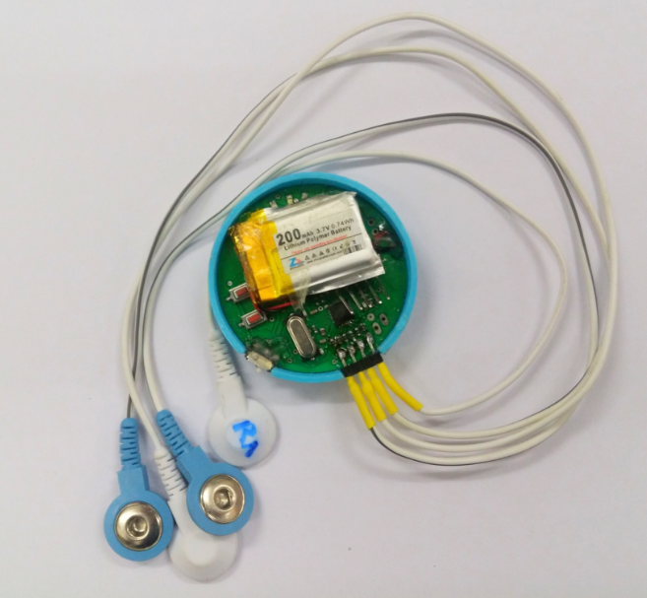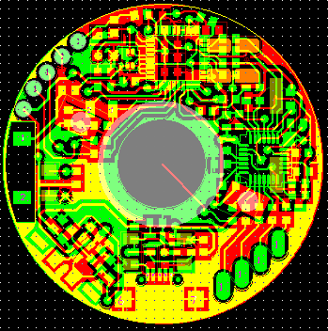

**Figure 20:** *Circuit layout and complete ECG device.*

For the telemedicine wireless transmission system, we successfully built a program on Android smartphone for communication between ECG module-smartphone-server. Moreover, a webpage server was programmed based on php language. Interfaces of two programs are shown in fig 21:

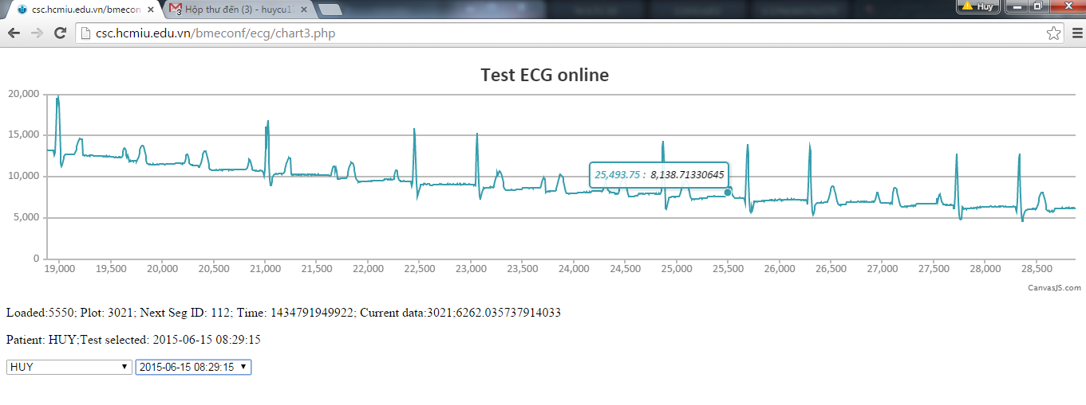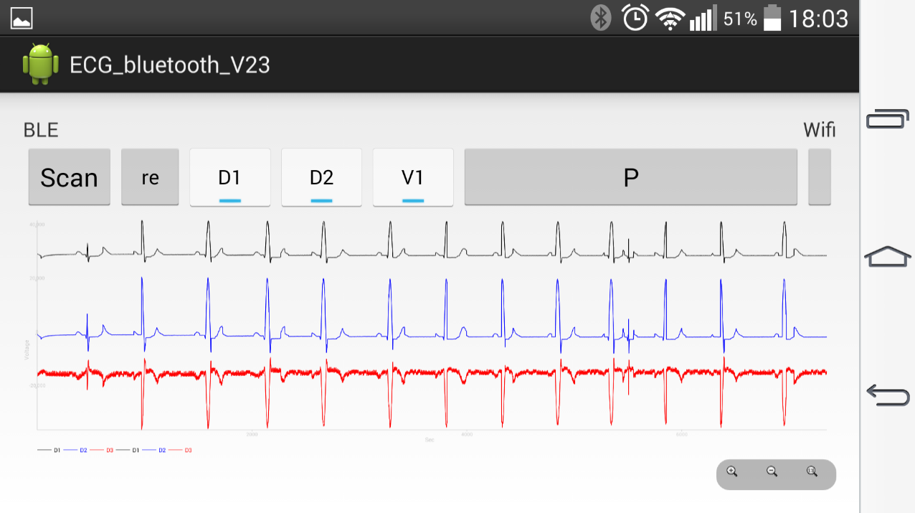

**Figure 21:** *Interface of Android program (above) and webpage (below)*

Besides, another function was added in Android smartphone in order to load data from database. Users need to choose first the patient id, which is the name and then the test id, which is date and time of the test. Then, the signal was loading and displaying on phone screen. Figure below show how it work:

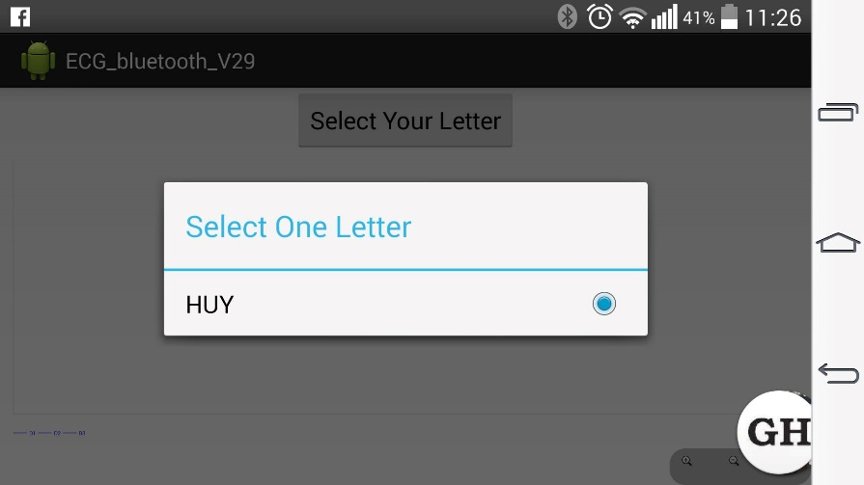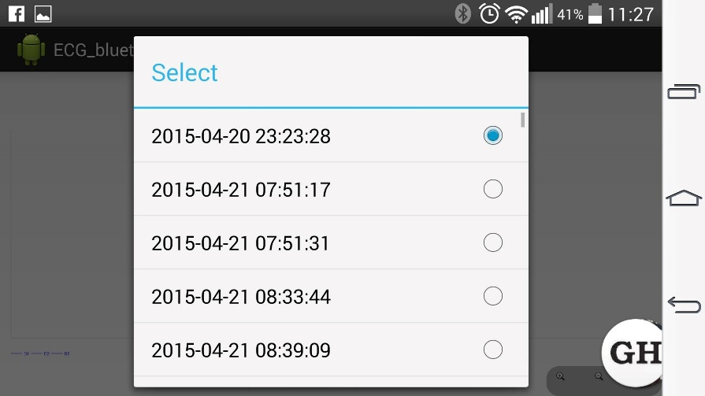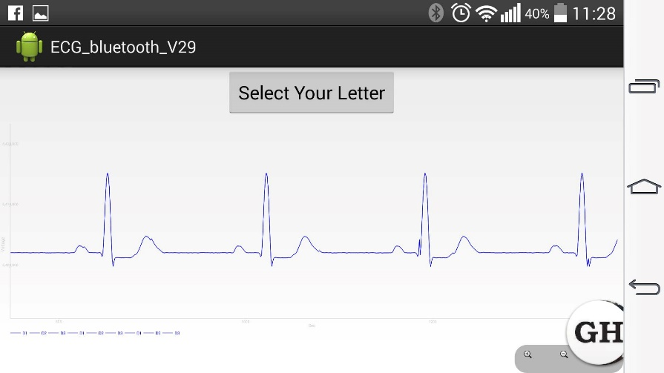

**Figure 22:** *Process to load data from server. First, user is asked to choose the patient id, which is the name. Then, a dialog will show up to ask for test id choosing. The test id is actually date and time of signal acquiring. The final result will be displayed on Android screen.*

4.2. Validation testing

4.2.1. Experimental settings

The ECG telemedicine system was tested in the Biosignal Processing Lab, Biomedical Engineering department at International University. The device was evaluated by comparing the acquired signal with the commercialized on the market. In this project, the Alice 5 diagnostic sleep system-Philips was chosen as reference. ECG signals were recorded from 2 sources: the multiparameter simulator MSP450, Fluke and real subject. 10 different kinds of ECG signals was recorded in 2 minutes with sampling rate of 500Hz for the comparison. Recorded signals from the developed devices and from Alice 5 were compare using MATLAB on both time and frequency domain. The cross correlation and power spectrum has been used. On real subject, basic positions were investigated including: lying, sitting, standing, and walking slowly and quickly.

4.2.2. Result on simulated signals

|  |  |  |  |  |  |  |  |
| --- | --- | --- | --- | --- | --- | --- | --- |
|  |  | Channel 1 | | | Channel 2 | | |
| No. | ECG types | Correlation amplitude | Lag | R square | Correlation amplitude | Lag | R square |
| 1 | Normal sinus rhythm | 32.7743 | 12 | 2.9705e-06 | 32.9901 | 21 | 4.1623e-06 |
| 2 | Adult ECG | 32.3188 | 15 | 2.7121e-05 | 32.5685 | 22 | 2.1699e-05 |
| 3 | Pediatric ECG | 15.3777 | -13 | 7.5671e-08 | 14.7753 | -33 | 9.5289e-07 |
| 4 | Atrial fibrillation | 35.1890 | -11 | 5.5484e-05 | 33.7883 | -22 | 1.2537e-04 |
| 5 | Atrial flutter | 32.7564 | -12 | 7.5671e-08 | 32.8983 | -24 | 7.5871e-08 |
| 6 | Sinus arrhythmia | 72.7827 | -15 | 7.2132e-06 | 71.2890 | -28 | 7.323e-06 |
| 7 | Missed beat | 45.3338 | 32 | 2.1343e-02 | 45.6734 | 64 | 2.1413e-02 |
| 8 | Atrial tachycardia | 34.2328 | 32 | 9.5221e-03 | 35.6423 | 66 | 8.5237e-03 |
| 9 | Nodal rhythm | 54.5332 | 12 | 4.5452e-04 | 54.2323 | 34 | 4.2213e-04 |
| 10 | Supraventricular tachycardia | 43.5332 | 23 | 3.3672e-05 | 43.5873 | 45 | 3.541e-05 |

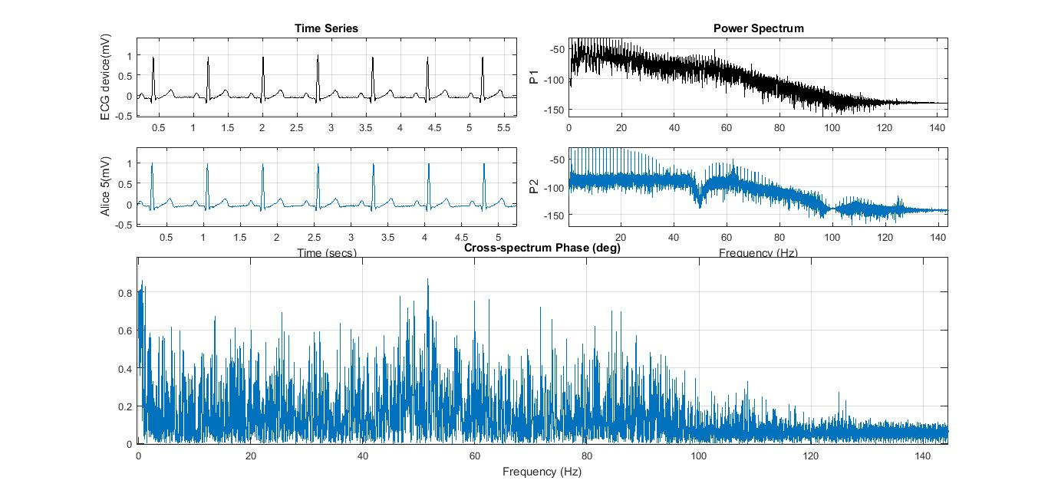

**Figure 23:** *Comparison between ECG device and Alice 5 ‘Normal sinus rhythm” signal from Fluke Simulator. The top figure represents ECG signals in time domain. 5 seconds of 2 minutes was considered for the comparison. The amplitudes and the intervals of the ECG peaks (P, QRS, and T) of these two signals are identical. On the top right, the power spectrum from 0 to 140Hz are were presented. On the bottom, coherence (quantifier that show the similarities of the signals in frequency domain) were calculated using function mscohere(). The x-axis represents for frequency while y-axis shows the magnitude. Maximum correlation coefficient were marked in the red circle at heart rate frequency around 1 Hz.*

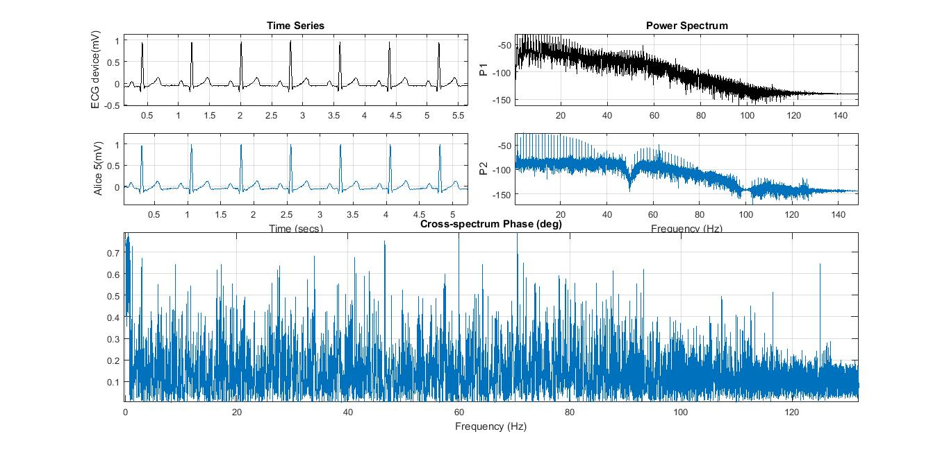

**Figure 24:** *Comparison between ECG device and Alice 5 ‘Normal Adult’ signal from Fluke Simulator. The top figure represents ECG signals in time domain. A segment of 5 seconds of signal from2 minutes of the signal has been used for the comparison. Virtually, these two signals are similar to each other. On the top right, the power spectrum was graphed. On the bottom, coherence of frequency were calculated using function mscohere(). The x-axis represents for frequency while y-axis shows the magnitude. Maximum correlation coefficient were marked in the red circles.*

4.2.3. Result on real patient

The picture below showed the experiment setup on human body in different postures and the signal captured by the developed device. The device’s footprints on the human chest are extremely small and cause no obstructive. The subject could even wear the device for all day without feeling uncomfortable. In additionally, the device has showed its ability to stick very hard on the human chest, there is no dislodge that has been recorded. The system is successfully recording the real signals that we can clearly see the ECG typically shape without filter.

Channel I

Channel II

Channel V1

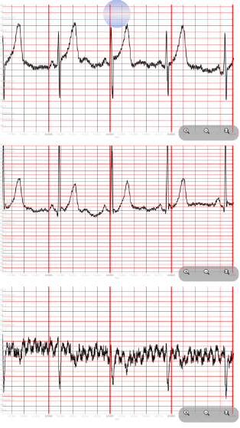

RA

LA

V1

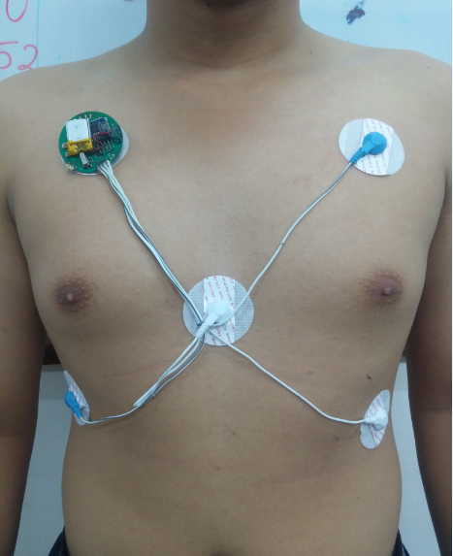

LL

RL

Figure 25: *ECG signal of standing subject*

Figure 1: *Experiment on standing subject*

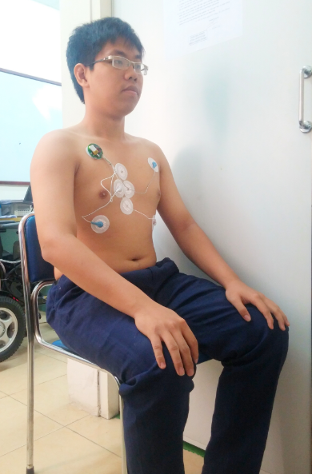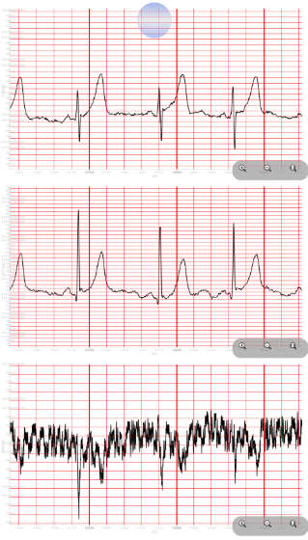

Figure 2: *ECG signal of sitting subject*

Figure 3: *ECG measurement when the subject is sitting*

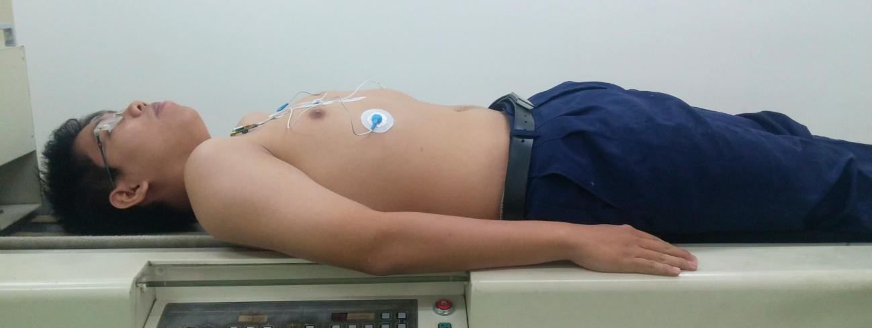

Figure 29: *The subject is lying*

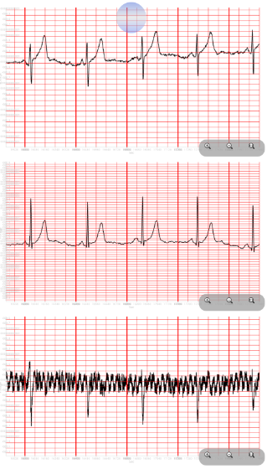

Figure 30: *ECG signal of lying subject*

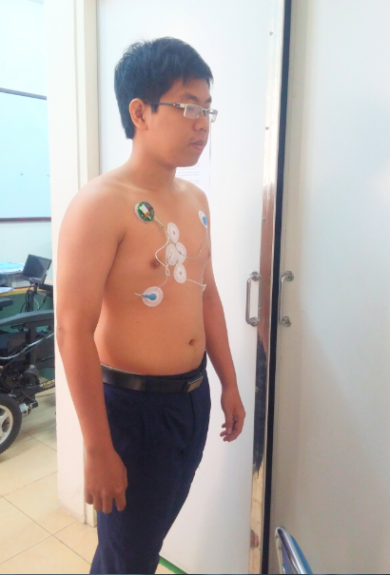

Figure 4: *The subject is walking*

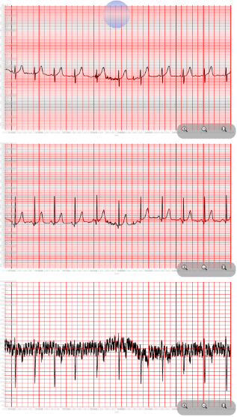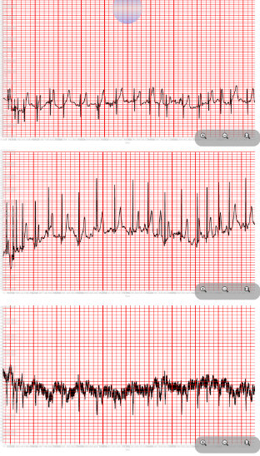

Figure 5: *The subject is walking slowly and fast*

Figure 43: ECG signal when the subject is walking quickly

Figure 6: ECG signal when the subject is walking slowly

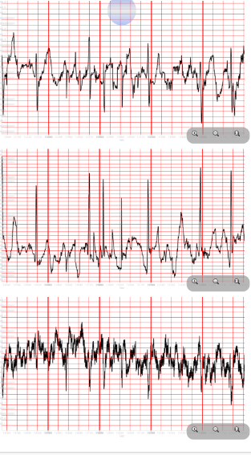

Figure 33: *ECG signal when the subject is running*

# CHAPTER 5

# IMPLEMENTATIONS AND DISCUSSIONS

The implemented device with ANALOG FRONT-END ECG AFE and CC2541 SoC has proved the reliability in recording both ECG signal from simulator and real human subjects. The subjects can wear the device for days without feeling uncomfortable. The quality of the device has been verified in the reality after being bought by a technician from Viet Gia Company. He bought this device due to the orders from his customers who are both doctor and normal user. This is a good sign to prove that the product of this project has the potential and the great possibility to be brought into the mass market and been accepted by both doctors and common users.

While preliminary results prove the viability of this project, there are a number of things that the author has learned during the design process to improve future revisions of the device. First, it has been noted that one of the most important part of the system is the battery. Power supply is the matter that challenges all the development of all technology device. Due to the limitation of budget and the size of this project, the current battery is still not fully compatible with the wearable device while cannot efficiently extend the life time of the device. Another reason for this drawback is the small size of the ECG device requires a minimum size of battery, this makes a consequence that the capacity of the battery is reduced.

One of the biggest challenge when gathering the bio-potential signal is to eliminate the noise, especially the voltage drift. One of the solution to avoid this phenomenon is using the high-pass filter. However, the ANALOG FRONT-END only provides the built-in digital low-pass filter, therefore the problem should be solved in the smartphone application.

This study proposed methods to implement wireless transmission into Holter ECG module. The result shows that signal is well transmitted from module to Android smartphone through BLE connection and from there to server via TCP/IP or Internet web-based server protocol. The signal was recording and transmitting smoothly and precisely. BLE protocol proposed high potential applications in telemedicine with close distant. TCP/IP sockets method is proved to be a highly performance protocol using in local area, while web-based server succeeded in globally usage.

Practical experiments showed some disadvantages of each protocol, which have been carefully considered and solutions was implemented.

First, in TCP/IP sockets method, the delay time between acquired signal and real ECG one causes by the duration of algorithm performance by MATLAB. According to our testing experiment, the acquisition time take about only 75% of total duration performed by program. The rest is used by processing signal. Therefore, the record is slower than real-time one about 25% in total. In order to deal with this problem, a low-level language, C-sharp, has been used to program an application to receive data. The result shows that, signal is transmitted smoother and faster due to the usage of multithread method, which allows many activities running parallel. Moreover, C-sharp is a low-level programming language, which requires low-cost of computation.

Second, the wireless transferring errors were still big issue to concentrate. In the recorded signal, there were both mistakes on Bluetooth pathway as well as TCP/IP one.

As the result, the errors mainly take place in the first step. These mistakes could be leaking bytes, or mismatch. The most important error is pairing 2 byte together. In this case, an extraordinary value appears among the normal one. This causes difficulties for signal processing after then. In order to solve this problem, a novel firmware is set, which let the MCU sending a 20-bytes package once instead of single byte one. Each package includes check byte and counter byte, which help to double-check the precision of sending data. The same method has been used to check data sending to server. There are record id, segment id and segment length for each package, which allow to check if there is any missing segment.

# CHAPTER 6

# CONCLUSIONS

In conclusion, the thesis work was successfully developed to be a completed device. The analog front-end circuit demonstrated the reliable work on capturing the real-time ECG signal without noises or delay. The wireless transceiver via BLE proved to be an excellent choice because of the compatibility with smartphone, high speed, and low power consumption. The device additionally showed the good experience when being worn on the chest of the patient. This proves that an ECG acquisition device can be made more comfortable without losing quality. This is feasible by intelligently integrating the wearable electronics, provided by TI, into a compact design. The author, being really multifaceted, covers a broad range of hardware as well as software skills. This gives the project the opportunity to successfully integrate a multitude of technology aspects and to bring to the mass market a promising wearable ECG system.

Telemedicine has been developed decades in other countries. However, in Vietnam and South East Asia countries, this is a new field. We are now find more projects that study about the applications and implementations of telemedicine in Vietnam, especially in Biomedical Engineering departments – HCMIU. Inspiring from those spirits, this project aims to build a complete tele-medical system for ambulatory electrocardiogram applications. In cooperating with the wireless ECG module, designed by other student, a novel transmitting pathway using Bluetooth Low Energy, TCP/IP sockets and Internet web-based server protocols is established.

In analysis aspects, BLE protocol performed fast and precisely in transmitting signal to Android smartphone. The maximum distance in practical experiment is 15 meters, with respects to 20 meters in reference. The further distance the slower performance. TCP/IP sockets protocol shows its advantage in speed and accuracy in data wireless transmission.

A new server program on C-sharp, which shows better performance in speed, is created to replace previous MATLAB vesion. This method should be more considered in hospital or clinics applications. Besides, the method of global web-based server has been proposed in order to overcome the local area usage limitationof TCP/IP sockets one. Although, the transmission of this method is unstable and slower, it is suitable for the high mobility users or emergency due to its wide range of transmission. 3G wireless system is implemented, which is expected to enhance the stability of signal.

For future applications, Holter ECG with wireless system is a potential solution for telemedicine, especially in heart diseases. This system gives patients and doctors chance to predict the occurrence of some dangerous diseases, such as silent ischemia. In addition, this is a first step for constructing complete telemedicine healthcare systems on the Internet.

# REFERENCES

1. Gacek, A.C. and W. Pedrycz, *ECG signal processing, classification, and interpretation: a comprehensive framework of computational intelligence*. 2012, London: New York Springer. x, 278 p.
2. Ozegowski, S., et al., *Usefulness of ambulatory ECG in the diagnosis of sleep-related breathing disorders.* (0022-9032 (Print)).
3. Barold, S.S., *Norman J. "Jeff" Holter-"Father" of ambulatory ECG monitoring.* J Interv Card Electrophysiol, 2005. **14**(2): p. 117-8.
4. Su, L., S. Borov, and B. Zrenner, *12-lead Holter electrocardiography. Review of the literature and clinical application update.* Herzschrittmacherther Elektrophysiol, 2013. **24**(2): p. 92-6.
5. Gibson, C.M., et al., *Diagnostic and prognostic value of ambulatory ECG (Holter) monitoring in patients with coronary heart disease: a review.* J Thromb Thrombolysis, 2007. **23**(2): p. 135-45.
6. Motskula, P.F., et al., *Prognostic value of 24-hour ambulatory ECG (Holter) monitoring in Boxer dogs.* J Vet Intern Med, 2013. **27**(4): p. 904-12.
7. Cygankiewicz, I., W. Zareba, and A.B. de Luna, *Prognostic value of Holter monitoring in congestive heart failure.* Cardiol J, 2008. **15**(4): p. 313-23.
8. Zanchi, E., et al., *Transient myocardial ischemia detected by Holter monitoring during the early post-infarction period.* Coron Artery Dis, 1995. **6**(5): p. 389-96.
9. Petretta, M., et al., *Detection of silent myocardial ischemia: is it clinically relevant?* J Nucl Cardiol, 2013. **20**(5): p. 707-10.
10. Gutterman, D.D., *Silent myocardial ischemia.* Circ J, 2009. **73**(5): p. 785-97.
11. Silva, B.M., et al., *Mobile-health: A review of current state in 2015.* J Biomed Inform, 2015.
12. Ward, M.M., M. Jaana, and N. Natafgi, *Systematic review of telemedicine applications in emergency rooms.* Int J Med Inform, 2015.
13. Widmer, R.J., et al., *Digital health interventions for the prevention of cardiovascular disease: a systematic review and meta-analysis.* Mayo Clin Proc, 2015. **90**(4): p. 469-80.
14. Raikhelkar, J. and J.K. Raikhelkar, *The impact of telemedicine in cardiac critical care.* Crit Care Clin, 2015. **31**(2): p. 305-17.
15. Gibson, J., et al., *Using telemedicine for acute stroke assessment.* Nurs Times, 2013.

**109**(35): p. 14-6.

1. Morales-Vidal, S. and S. Ruland, *Telemedicine in stroke care and rehabilitation.* Top Stroke Rehabil, 2013. **20**(2): p. 101-7.
2. Bifulco, P., et al., *Telemedicine supported by Augmented Reality: an interactive guide for untrained people in performing an ECG test.* Biomed Eng Online, 2014. **13**: p. 153.
3. Hsieh, J.C. and M.W. Hsu, *A cloud computing based 12-lead ECG telemedicine service.*

BMC Med Inform Decis Mak, 2012. **12**: p. 77.

1. Otsuka, Y., H. Yokoyama, and H. Nonogi, *Novel mobile telemedicine system for real-time transmission of out-of-hospital ECG data for ST-elevation myocardial infarction.* Catheter Cardiovasc Interv, 2009. **74**(6): p. 867-72.
2. Patricoski, C. and A.S. Ferguson, *ECG acquisition using telemedicine in Alaska.* Alaska Med, 2003. **45**(3): p. 60-3.
3. de Jongh, T., et al., *Mobile phone messaging for facilitating self-management of long- term illnesses.* Cochrane Database Syst Rev, 2012. **12**: p. CD007459.
4. Aust, M.P., *Intensive care unit telemedicine.* Am J Crit Care, 2012. **21**(1): p. 34.
5. Brunetti, N.D., et al., *Telemedicine for cardiovascular disease continuum: A position paper from the Italian Society of Cardiology Working Group on Telecardiology and Informatics.* Int J Cardiol, 2015. **184**: p. 452-458.
6. Omre, A.H., *Bluetooth low energy: wireless connectivity for medical monitoring.* J Diabetes Sci Technol, 2010. **4**(2): p. 457-63.
7. Masuch, J. and M. Delgado-Restituto, *A 1.1-mW-RX <formula formulatype="inline">*

*<img src="/images/tex/20811.gif" alt="{, #694}{\hbox {81.4}}"> </formula>-dBm Sensitivity CMOS Transceiver for Bluetooth Low Energy.* Microwave Theory and Techniques, IEEE Transactions on, 2013. **61**(4): p. 1660-1673.

1. Kim, H., et al., *A configurable and low-power mixed signal SoC for portable ECG monitoring applications.* IEEE Trans Biomed Circuits Syst, 2014. **8**(2): p. 257-67.
2. Cho, G.Y., S.J. Lee, and T.R. Lee, *An optimized compression algorithm for real-time ECG data transmission in wireless network of medical information systems.* J Med Syst, 2015. **39**(1): p. 161.
3. Ma, T., et al., *Assurance of energy efficiency and data security for ECG transmission in BASNs.* IEEE Trans Biomed Eng, 2012. **59**(4): p. 1041-8.
4. Lee, S., J. Kim, and M. Lee, *A real-time ECG data compression and transmission algorithm for an e-health device.* IEEE Trans Biomed Eng, 2011. **58**(9): p. 2448-55.
5. Rezai-Rad, M., R. Vaezi, and F. Nattagh, *E-health readiness assessment framework in iran.* Iran J Public Health, 2012. **41**(10): p. 43-51.
6. Martinez-Perez, B., et al., *Mobile apps in cardiology: review.* JMIR Mhealth Uhealth, 2013. **1**(2): p. e15.
7. Gregoski, M.J., et al., *Development and validation of a smartphone heart rate acquisition application for health promotion and wellness telehealth applications.* Int J Telemed Appl, 2012. **2012**: p. 696324.
8. Hernandez, A.I., et al., *Real-time ECG transmission via Internet for nonclinical applications.* Information Technology in Biomedicine, IEEE Transactions on, 2001. **5**(3): p. 253-257.
9. De Capua, C., A. Meduri, and R. Morello, *A Smart ECG Measurement System Based on Web-Service-Oriented Architecture for Telemedicine Applications.* Instrumentation and Measurement, IEEE Transactions on, 2010. **59**(10): p. 2530-2538.
10. Yen, T.H., C.Y. Chang, and S.N. Yu, *A portable real-time ECG recognition system based on smartphone.* Conf Proc IEEE Eng Med Biol Soc, 2013. **2013**: p. 7262-5.
11. Anpeng, H., et al., *WE-CARE: An Intelligent Mobile Telecardiology System to Enable mHealth Applications.* Biomedical and Health Informatics, IEEE Journal of, 2014. **18**(2): p. 693-702.
12. Goldberger, A.L., et al., *PhysioBank, PhysioToolkit, and PhysioNet: Components of a New Research Resource for Complex Physiologic Signals.* Circulation, 2000. **101**(23): p. e215- e220.
13. Creation, B. *Bluetooth smart*. Available from: https://[www.bluecreation.com/bluetooth-](http://www.bluecreation.com/bluetooth-smart-5-94.html) [smart-5-94.html.](http://www.bluecreation.com/bluetooth-smart-5-94.html)